CH4203: Organic Chemistry Laboratory
Exp: Multicomponent reaction: Ugi reaction
Aim & Objective: We will learn a multicomponent Ugi reaction in this lab. Ugi reaction involved ketone or aldehyde, amine, isocyanide, and carboxylic acid. The reaction is named after Ivan Karl Ugi, who first reported this reaction in 1959.
Apparatus Requirement:
- One 25 mL RB,
- 10 mL measuring cylinder
- 50 mL conical flask
- 100 mL separating funnel
- 2 plastic funnels, Spatula, Test tube, Column
Chemicals Requirement:
- Benzoic acid
- Aniline
- Benzaldehyde
- Tert-butyl isocyanide
- EtOAc, Distilled water

Reaction Scheme:
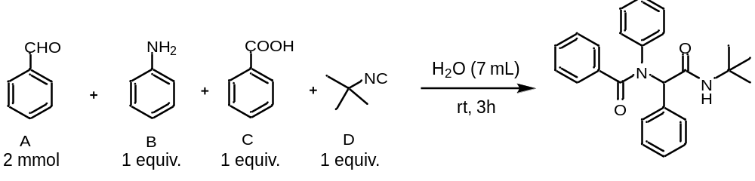

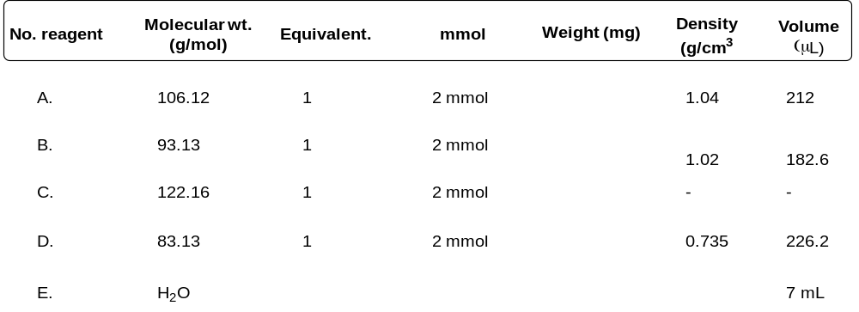
Method: Benzaldehyde (2 mmol, 0.21 mL), aniline (2 mmol, 0.18 mL), benzoic acid (2 mmol, 0.25 g), and tert-butyl isocyanide (2 mmol, 0.22 mL) were placed in a round bottom flask containing 7 mL of water . The reaction mixture is left with magnetic stirring for the 3h at room temperature. Subsequently, the reaction mixture is diluted with saturated NaHCO₃ solution (15.0 mL) and extracted with ethyl acetate (2 x 20 mL), and then the organic layer is washed with saturated NaCl solution. Dry over anhydrous Na₂SO₄, filter, and evaporate the solvent under reduced pressure. The crude obtained is purified by column chromatography (flash SiO₂, Hexane: Ethyl acetate (8: 2)) to give a white solid.
R_{f} value: (20% EtOAc/hexane) = 0.25
Characterization of Product:
The final product was characterized by IR spectra, ¹H NMR spectra, ¹³C NMR spectra.
Results & Observation:

Yield: X g % of Yield: XX% MP: XX – XX °C

% of ee: XX%

TLC System: R_{f} = 0.XX (20% EtOAc in n-hexane)

Compound Characterization:

IR Frequencies: cm⁻¹

¹H-NMR: (500 MHz, CDCl₃) δ

¹³C-NMR: (126 MHz, CDCl₃) δ

Conclusion:

